1. Styling with CSS
Prepared: TrangNTT
Lab 11. 1. Styling with CSS 1
11.1. Macromedia DreamWeaver 2
11.2. Embedded style 4
11.3. External style 6
11.4. Text properties 7

Macromedia DreamWeaver

Install Macromedia Dream Weaver to design HTML & CSS

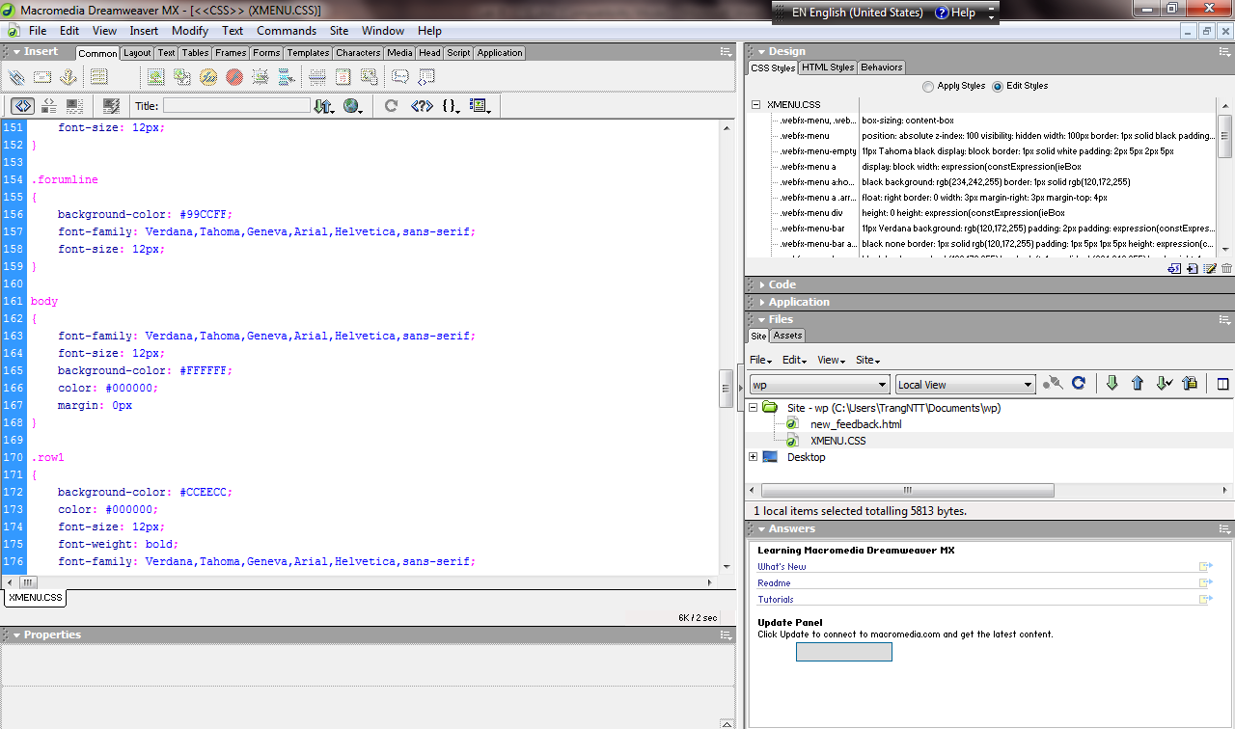
Design CSS

Basic operations
            - New Document: Go to menu File → New
              - HTML
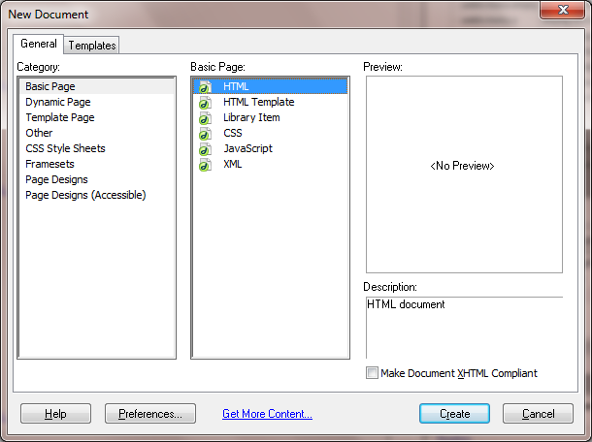
              - CSS: No Template or with Template
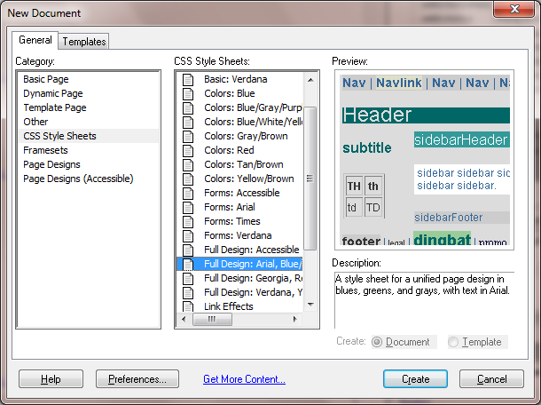
            - Change Properties of an element/tag
              - Choose the element/tag
              - Change properties in the Properties view
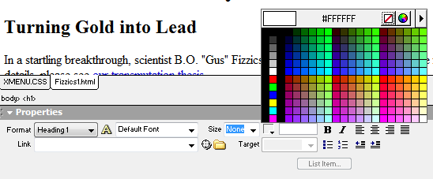

Embedded style

Create Fizzics1.html (no style sheet)
You can copy the following code so that you donot have to re-enter. Note that choose View → Code and Design to see both code and it’s preview as in the browser.
<!DOCTYPE HTML PUBLIC "-//W3C//DTD HTML 4.0 Transitional//EN">
<HTML>
<HEAD>
<TITLE>New Advances in Physics</TITLE>
</HEAD>
<BODY>
<H1>New Advances in Physics</H1>
<H2>Turning Gold into Lead</H2>
In a startling breakthrough, scientist B.O. "Gus" Fizzics has invented a <STRONG>practical</STRONG> technique for transmutation! For more details, please see <A HREF="give-us-your-gold.html">our transmutation thesis</A>.
<H2>Perpetual Inactivity Machine</H2>
In a radical approach that turned traditional attempts to develop perpetual motion machines on their heads, Prof. Fizzics has developed a verified, bona fide perpetual inaction machine. To purchase your own for only $99.00 (plus $43.29 shipping and handling), please see our order form.
</BODY>
</HTML>
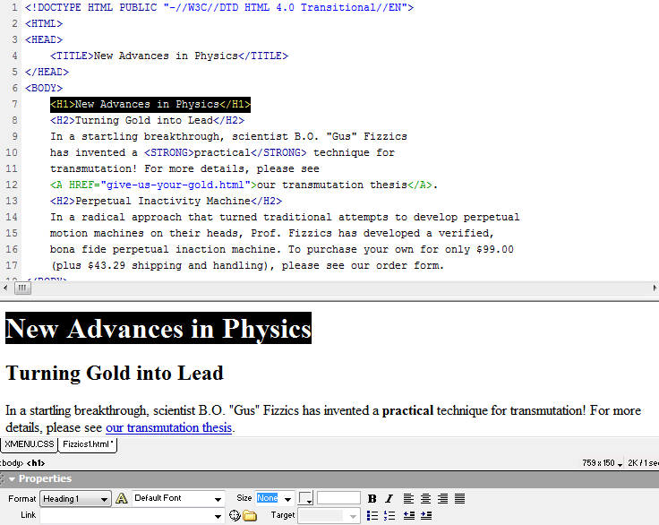

Save as Fizzics2.html
Add <STYLE TYPE=”text/css”> … </STYLE> to the HEAD part of the Fizzics1.html as the following, observe the result. Download the confetti-background.jpg and put it in the images directory.
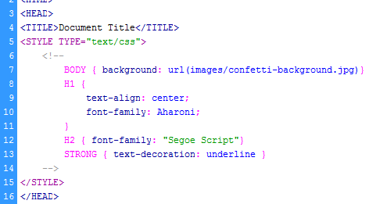
Result:
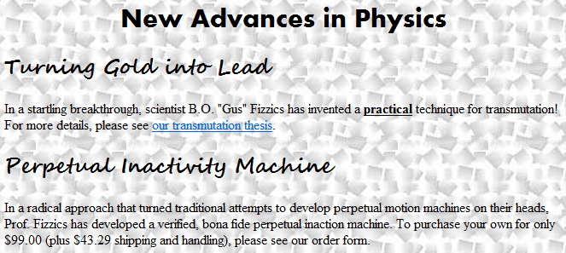

External style

Cabinets.html
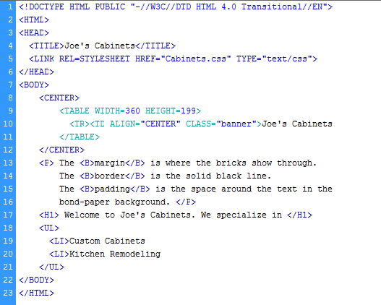

Cabinets.css
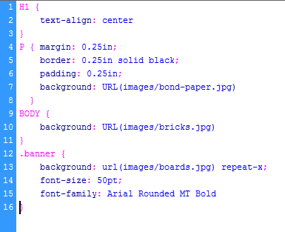

Result
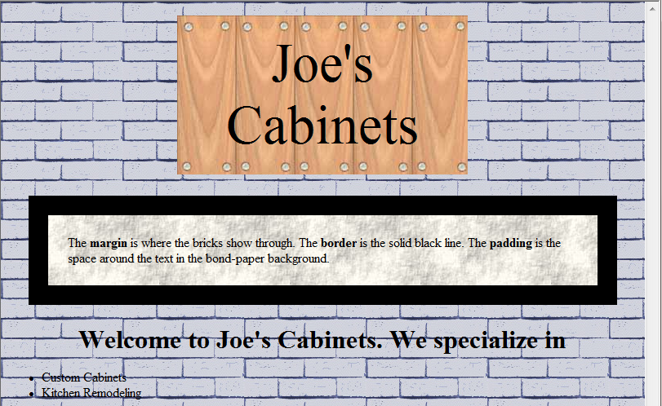

Text properties

Bates.html
You can copy the following code:
<!DOCTYPE HTML PUBLIC "-//W3C//DTD HTML 4.0 Transitional//EN">
<HTML>
<HEAD>
<TITLE>An Open Letter to the IRS</TITLE>
<LINK REL=STYLESHEET HREF="Bates.css" TYPE="text/css">
</HEAD>
<BODY BACKGROUND="images/bond-paper.jpg">
<P CLASS="rhead">
April 1, 2001
<HR>
<P CLASS="rhead">
William A. Bates<BR>
Macrosoft Corporation<BR>
Blumond, WA 12345
<P CLASS="lhead">
Internal Revenue Service<BR>
Philadelphia, PA 67890
<P>
<BR>
Dear Sirs,
<P CLASS="body">
I am writing to inform you that, due to financial difficulties, I will be unable to pay my taxes this year.
<P CLASS="body">
You see, my company has had reduced profits this year. In fact gross revenues have now dropped below the GDP of <B>twelve</B> foreign countries! Given this intolerable situation, I am sure you will understand.
<H2 ALIGN="CENTER">
The 23rd Psalm (King James Version)</H2>
<SPAN>T</SPAN>he LORD is my shepherd; I shall not want.
<P> He made me to lie down in green pastures: he led me beside the still waters. He restoreth my soul: he leadeth me in the paths of righteousness for his name's sake. Yea, though I walk through the valley of the shadow of death, I will fear no evil: for thou art with me; thy rod and thy staff they comfort me. Thou preparest a table before me in the presence of mine enemies: thou anointest my head with oil; my cup runneth over. Surely goodness and mercy shall follow me all the days of my life: and I will dwell in the house of the LORD for ever.
<P CLASS="foot">
Sincerely,<BR>
William A. Bates
</BODY>
</HTML>

Bates.css
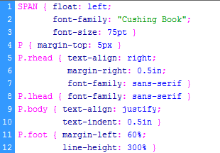

Result
